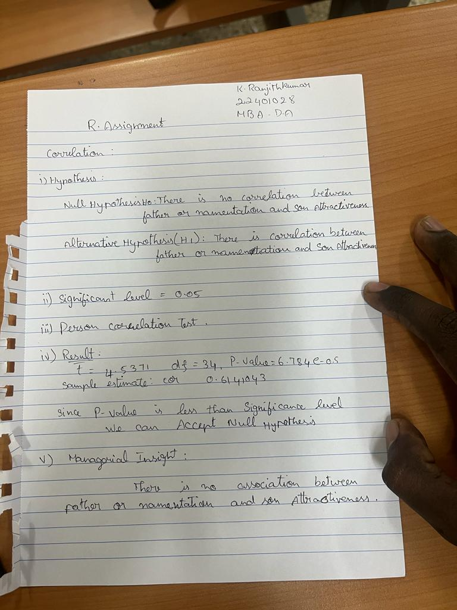The given code performs various statistical analyses on the variables "fatherOrnamentation" and "sonAttractiveness" in the dataset FSA. Here is a summary of the results obtained:

1. Pearson's correlation coefficient: The Pearson correlation coefficient between fatherOrnamentation and sonAttractiveness is 0.6141043. This indicates a moderate positive correlation between the two variables.
2. Coefficient of determination: The correlation of determination, obtained by squaring the Pearson correlation coefficient, is 0.377124. It represents the proportion of the variability in sonAttractiveness that can be explained by fatherOrnamentation.
3. Correlation significance test: The correlation significance test confirms that the correlation is statistically significant. The test reports a t-value of 4.5371, degrees of freedom (df) of 34, and a p-value of 6.784e-05. The alternative hypothesis suggests that the true correlation is not equal to 0. The 95% confidence interval for the correlation ranges from 0.3577455 to 0.7843860.
4. Spearman's rank correlation: The Spearman correlation coefficient between fatherOrnamentation and sonAttractiveness is 0.5792287. Spearman's correlation is a non-parametric measure that assesses the monotonic relationship between variables.
5. Linear regression: A linear regression model is fitted to predict sonAttractiveness based on fatherOrnamentation. The estimated coefficients are:
   * Intercept: 0.005084
   * FSA$fatherOrnamentation: 0.982285
6. Plotting: Two scatter plots are generated to visualize the relationship between fatherOrnamentation and sonAttractiveness. The first plot includes a linear regression line, while the second plot excludes the standard error of the line.
7. Residual analysis: Residuals (the differences between observed and predicted values) are calculated using the linear regression model. A plot of residuals against fatherOrnamentation is created, and an abline is drawn at y = 0 to assess the homoscedasticity assumption.
8. Summary statistics of residuals: The mean of the residuals is approximately 4.409917e-17, indicating that, on average, the residuals are close to zero. The median of the residuals is -0.02118666.
9. Mode calculation: A custom function called "mode" is defined to calculate the mode of the FSA dataset. However, the code for this function is incomplete and throws an error.
10. Kolmogorov-Smirnov test: The residuals are tested for normality using the Kolmogorov-Smirnov test with a null hypothesis that the data follows a normal distribution. The test yields a test statistic (D) of 0.30419 and a p-value of 0.002556. The p-value suggests evidence against the null hypothesis, indicating that the residuals may not be normally distributed.

In summary, the analyses indicate a moderate positive correlation between fatherOrnamentation and sonAttractiveness. A linear regression model suggests that fatherOrnamentation is a significant predictor of sonAttractiveness. The residuals show some departure from normality, indicating the need for further investigation or potential model improvement.